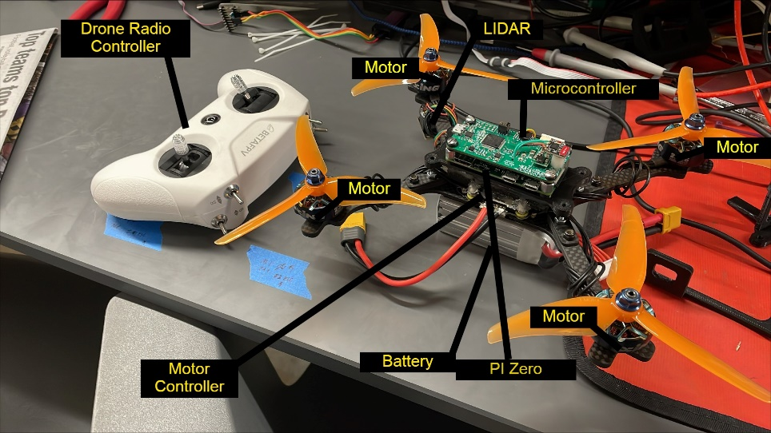

**Pi and Microcontroller communication:**

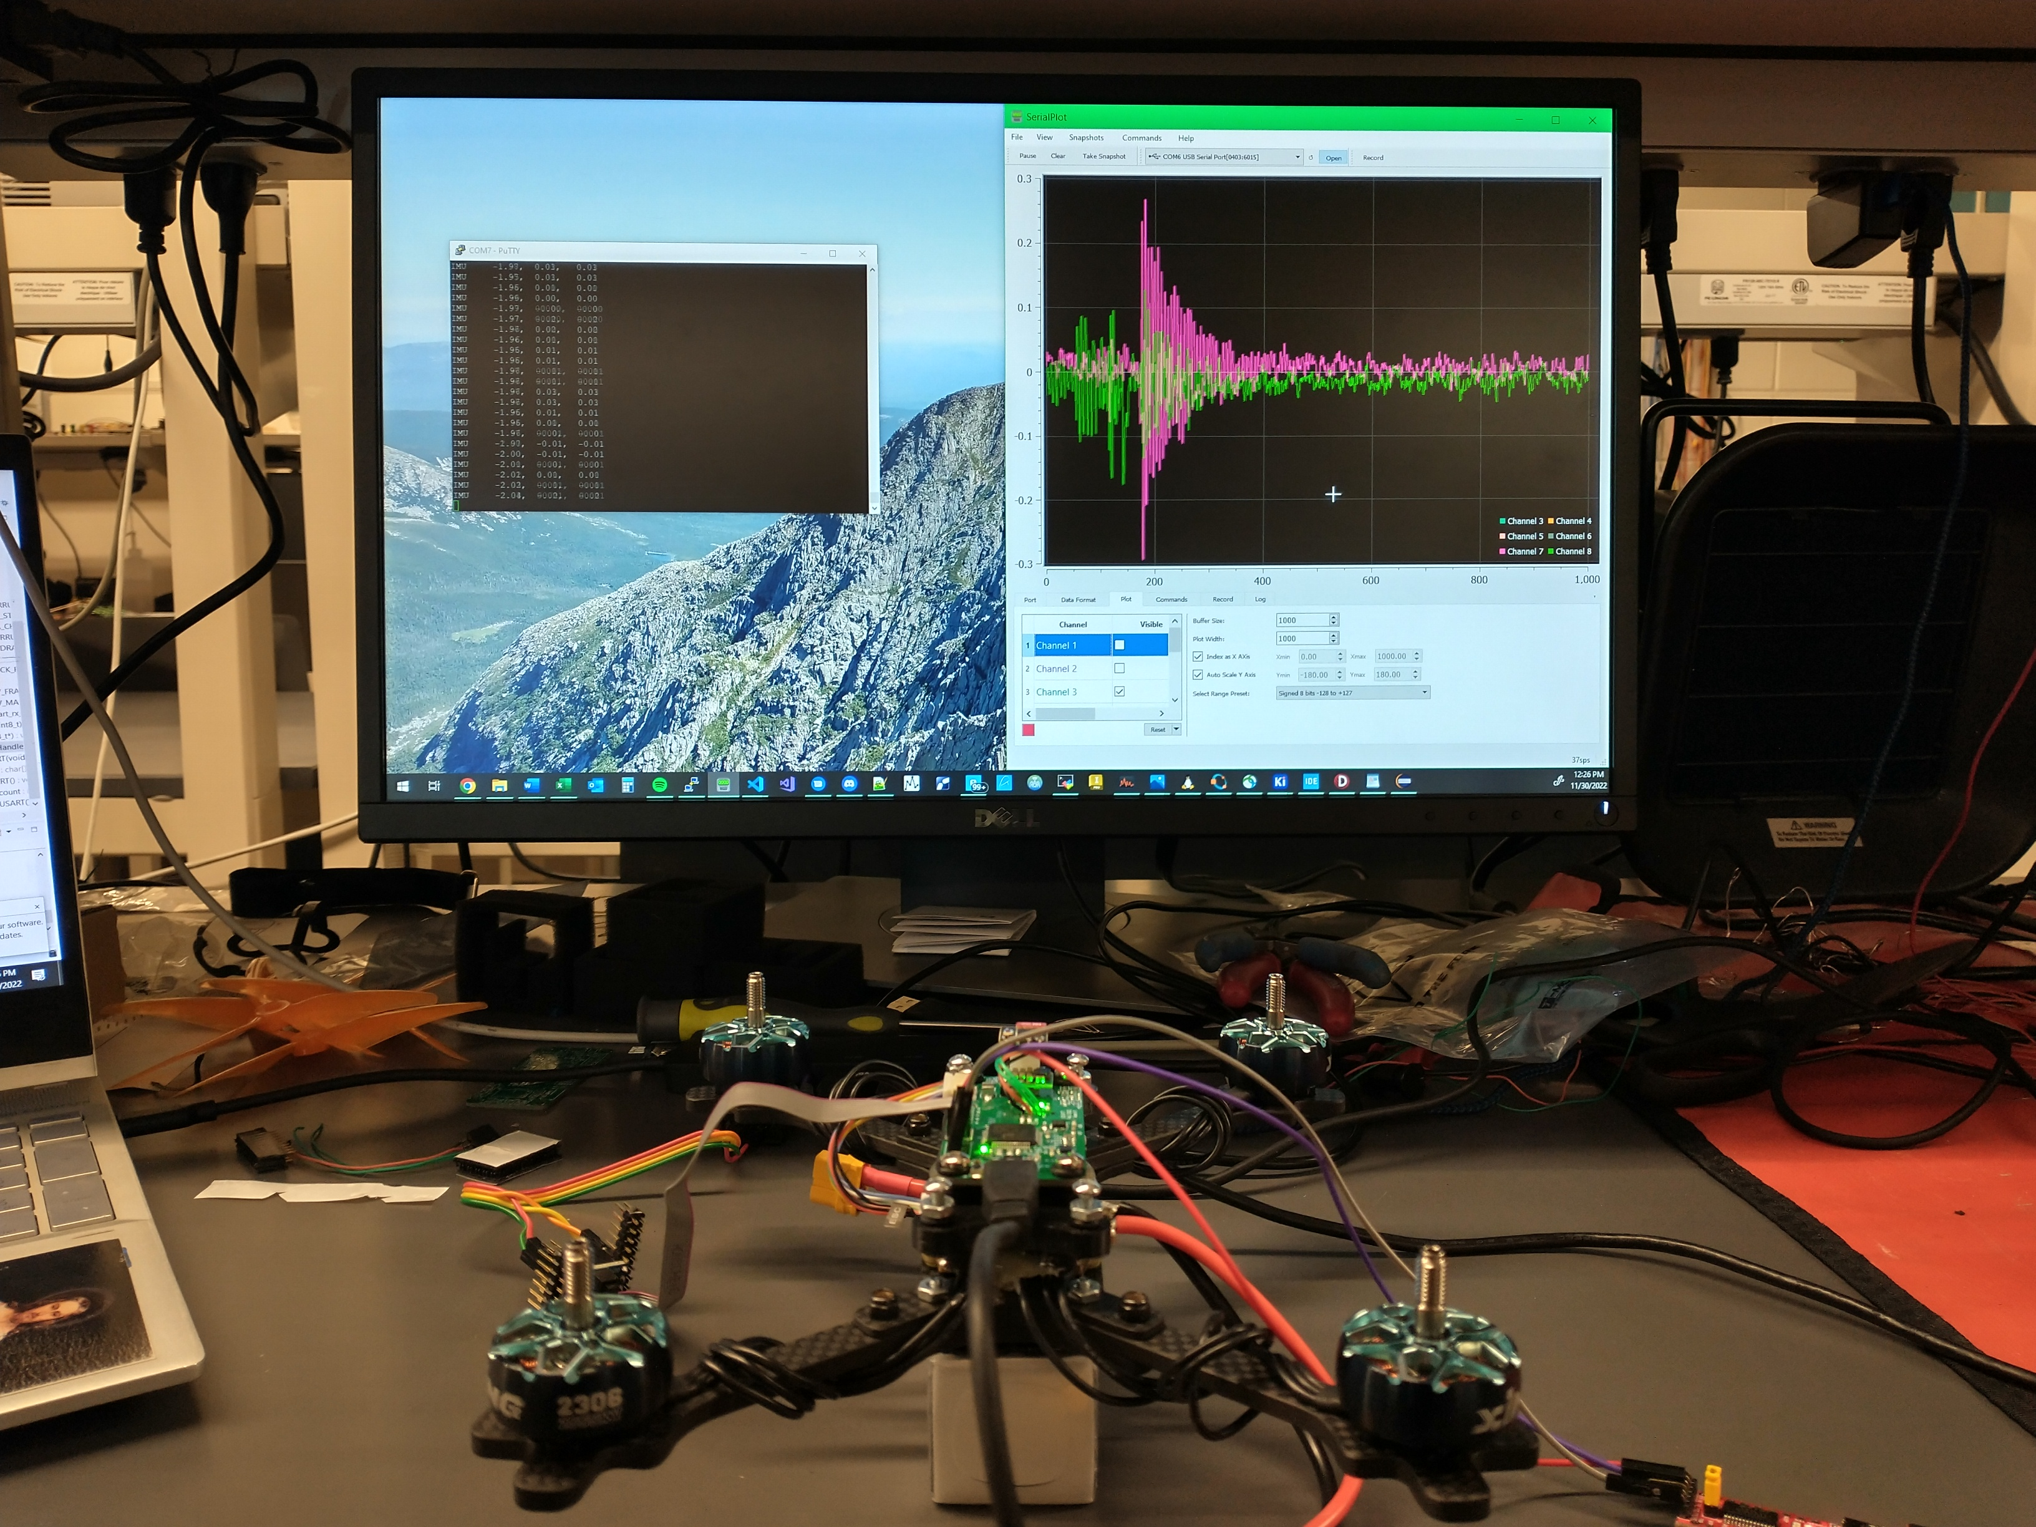

Pi and Microcontroller communicating via UART will be used to log data and determine flight path in autonomous mode.

**Microcontroller and Support Circuitry:**

Pi Zero, Pi Camera, TMF8801 1D Time-of-flight sensor, VL53L1X Time of Flight Sensor, T-Motor Velox V2 ESC, and our microcontroller is the STM32F446

Hermes Team

**LIDAR Sensors:**

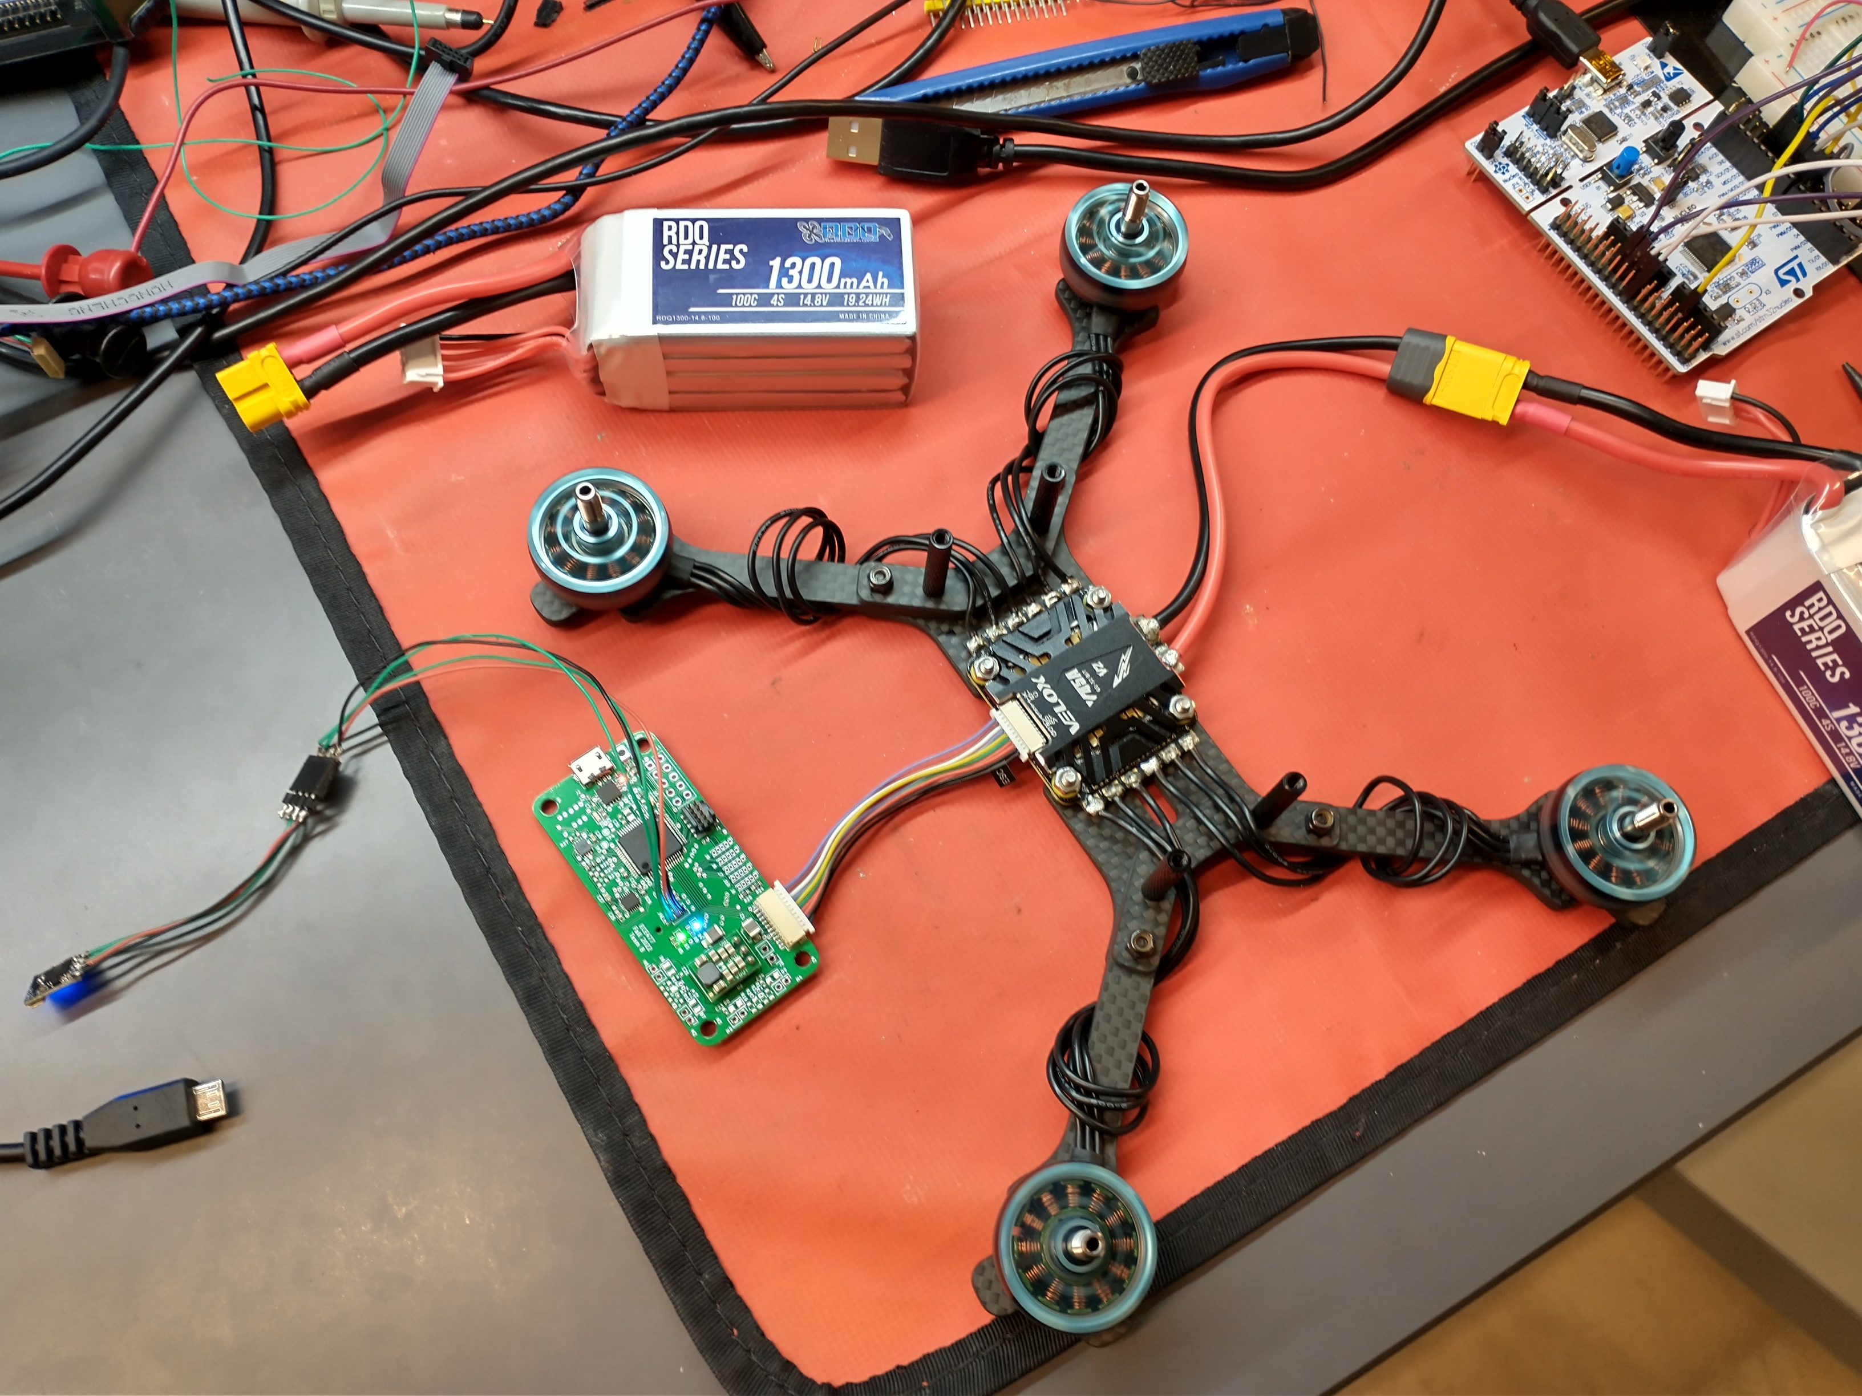

The LIDAR sensors will be placed at the front, back, left and right of the drone. The 4 VL53L1X will be connected to the Pi Zero and the TMF8801 is connected to the microcontroller.

**Problem:** On average around the world there are a total of 8 building collapses a year around the world. An average of 38 people die and many more are left injured and in need of rescue.

**Project Goal:** Assist rescues in their task of finding injured peoples and make their job safer.

**Our Solution:** An automated drone that uses LIDAR sensors, a Pi Zero and a microcontroller to calculate and follow a flight path to move around inside a building to identify where people are found.

**ECE 477 Digital Systems Senior Design Project – Fall 2022**

**Team 8 / Hermes**